Trouble-Shooting Error Documents

Previously the website was running smoothly
Now I have deleted one record <Record A is deleted>
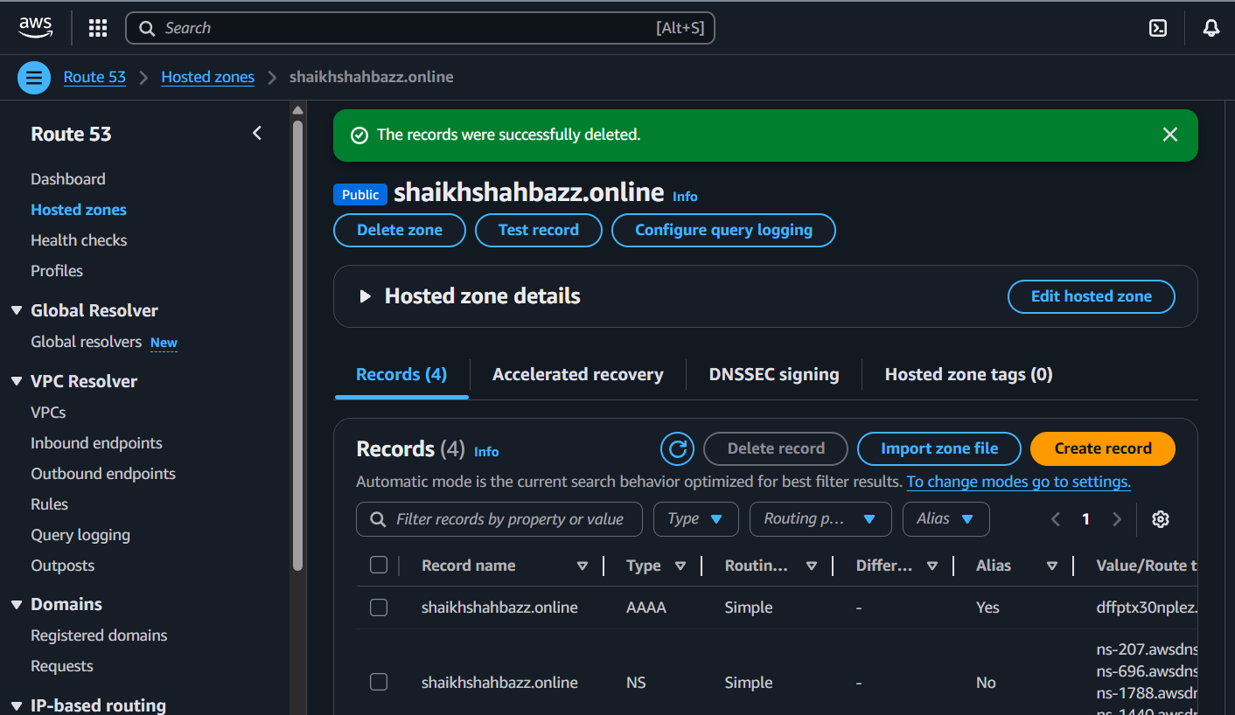
Then tried connecting the website with domain name
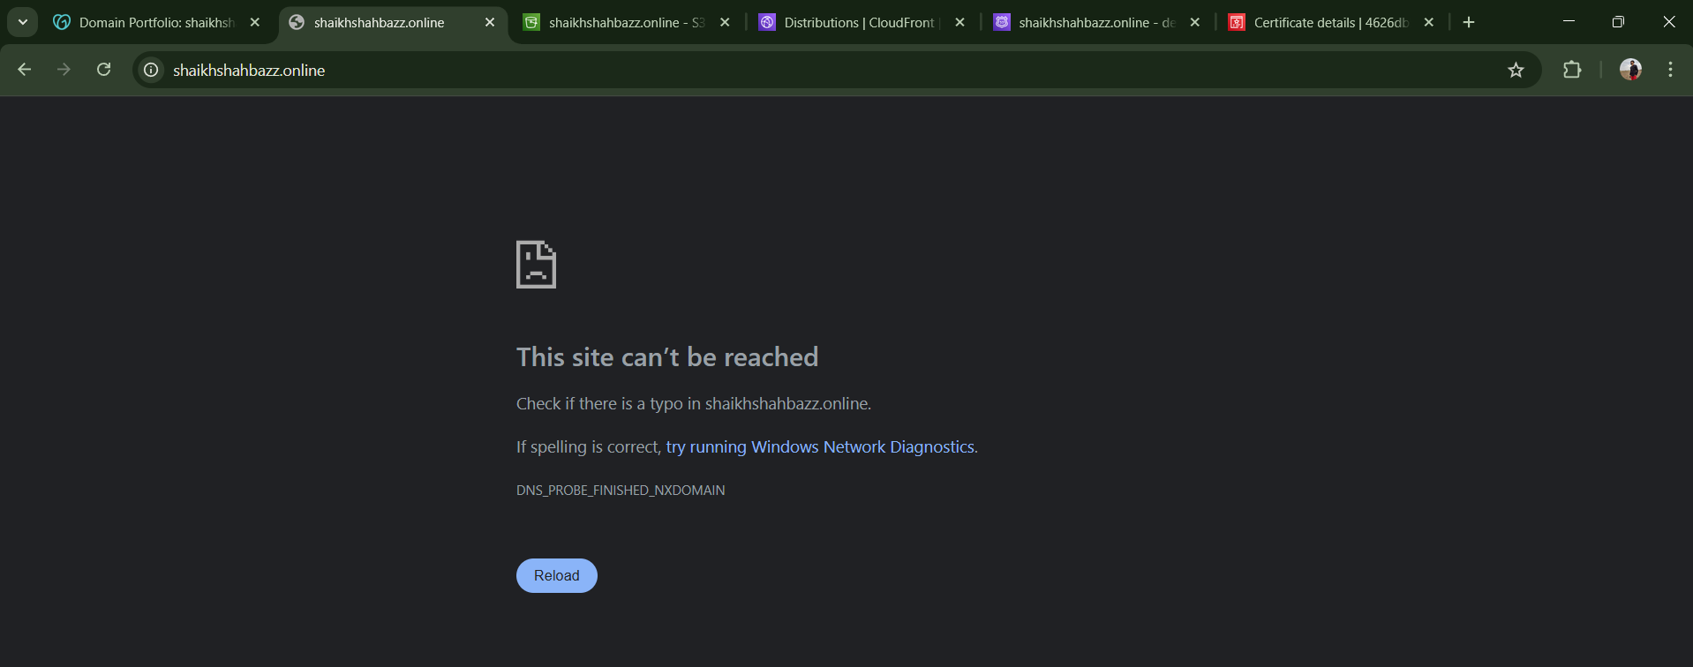

Now I will start from checking Static website in S3-bucket
To check with the files <index and error> and tried make them public but the option is desabled
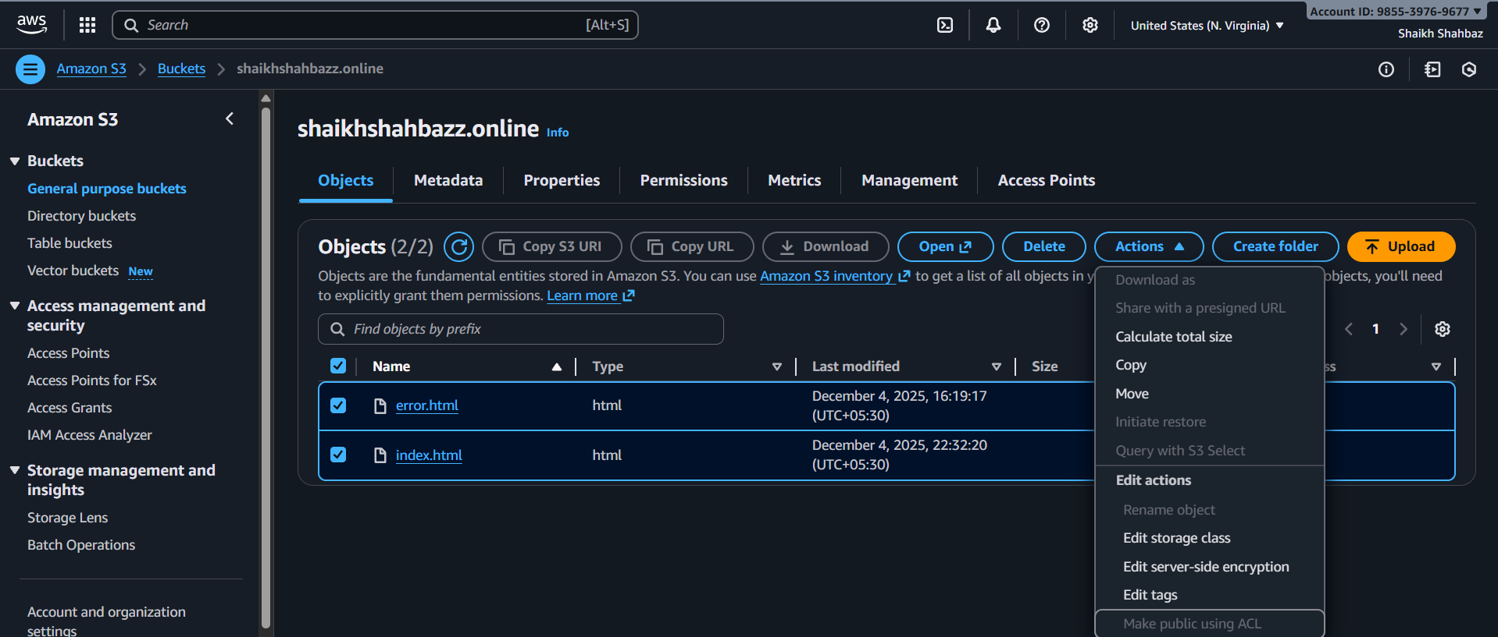

Now I will check cloudfront Distribution tab for records
Here we can see that A record is missing or got deleted by someone
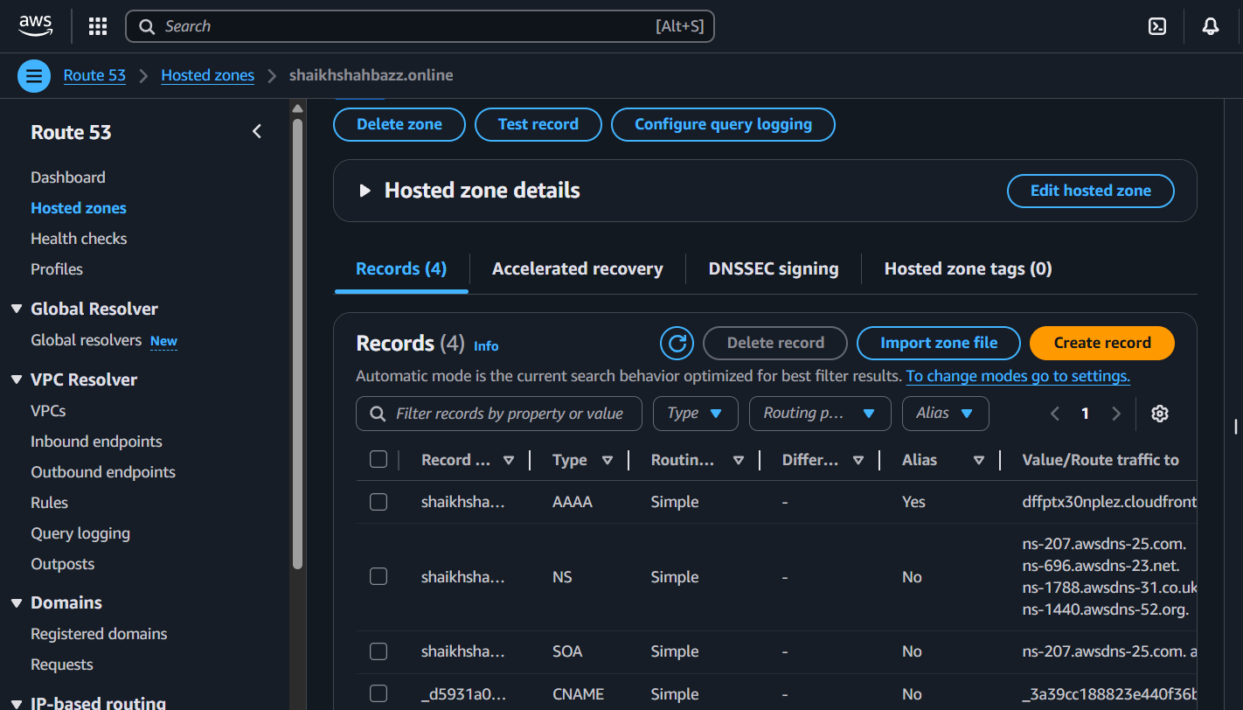

Now we will create A record and see if the website will get back to running state or not
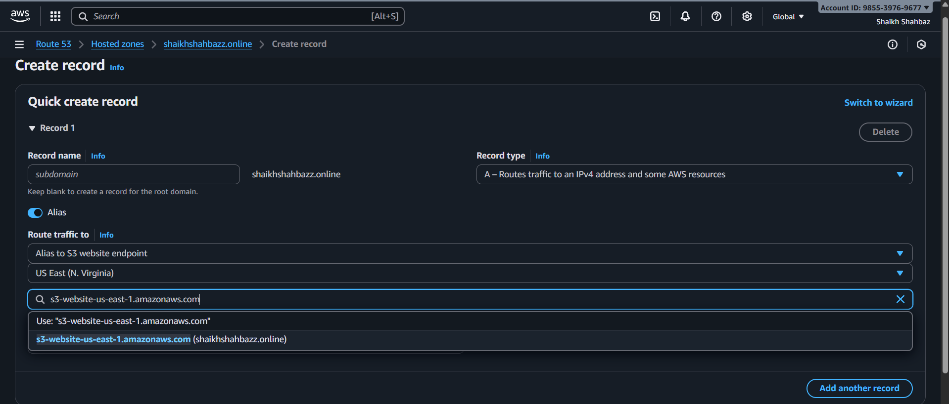
Here we will create A record
Steps :
First we will select A type by default
Enable Alias
In route traffic tab
Alias s3 website endpoints because we are hosting static website
using s3-bucket
Then we will select the region where our we r creating the record <N.Virginia>
Then we create a record
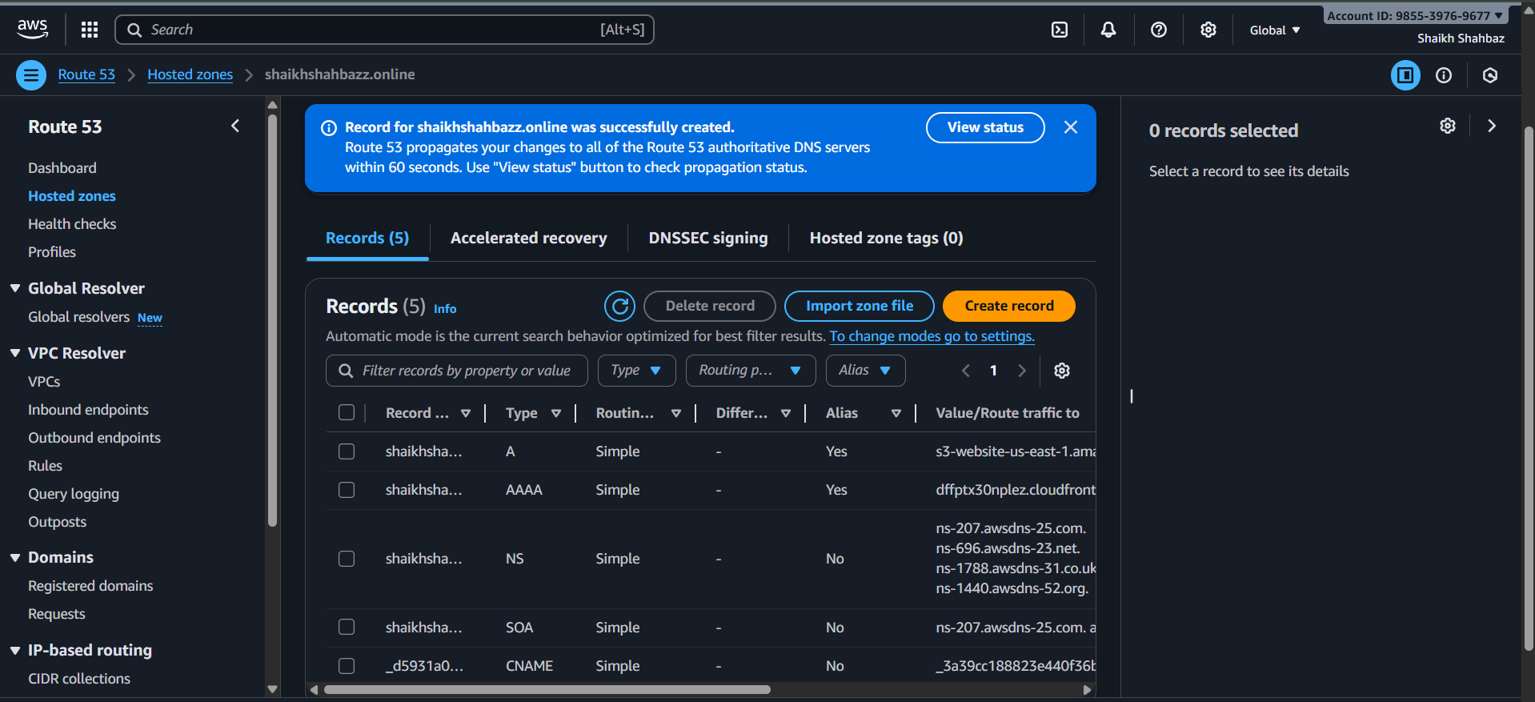
Now we will check in cloudfront distribution for <setup routing automatically>
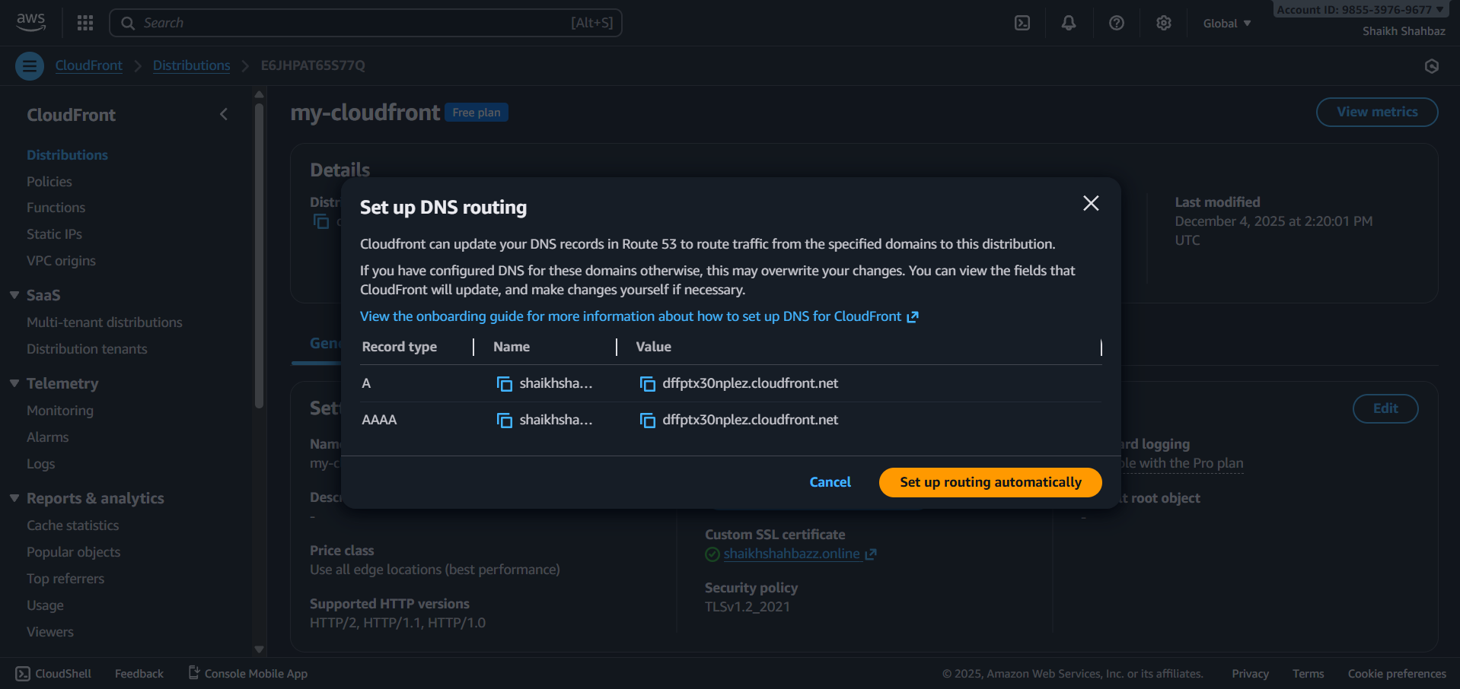
Now after seting up routing automatically
Then checked for website in browser Successfully we got back the domain or website active and running
